A psychologist studying the dynamics of marriage wanted to know how many hours per week the average American couple spends discussing marital problems. In this hypothetical study the sample mean of 70 randomly selected couples turned out to be 2.6 hours, with s = 1.9. Suppose a European study had already estimated the population mean to be 3 hours per week for European couples. Are the American couples significantly different from the European couples?

* 1. State your hypotheses (in words & symbols)
     1. H0: Mu_american = Mu_european. There is no difference between the American couples and the European couples on time spent discussing marital problems.
     2. H1: Mu_american != Mu_european. There is a difference between the American couples and the European couples on time spent discussing martial problems.
  2. Conduct a one-sample two-tailed t-test at the alpha = .05 level.
     1. calculate the test statistic (t)

(2.6 - 3)/(1.9/sqrt(70)) = -1.76139

1. find the critical value

df = n-1 = 70-1 = 69

tcv(69) = +- 1.99

1. compare – we have a negative test statistic – is it MORE negative than our negative critical value? (see picture).

Answer: No. SO, we fail to reject the null.

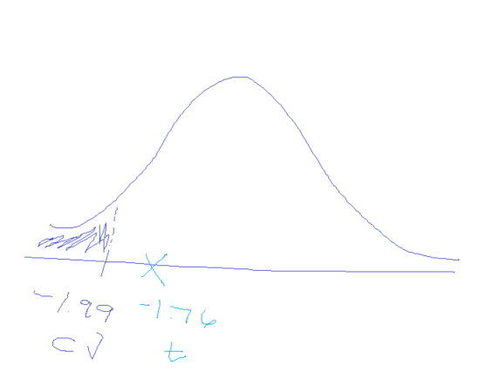

* 1. Write the conclusion in APA format.
     1. A one-sample two-tailed t-test revealed no significant difference between the time spent discussing martial problems between the American couples (M=2.6) and the European population study (Mu=3.0), t(69)= -1.74, p>.05.